IHE Brief Proposal template

1. Proposed Work item: Uniformal barcode processing for patient safety and efficiency

* Proposal Editor: *<Erik Zwarter, ErasmusMC Rotterdam and Esther Peelen, GS1 Netherlands>*
* Editor: *<Vincent van Pelt, Nictiz>*
* Date: N/A (Wiki keeps history)
* Version: N/A (Wiki keeps history)
* Domain: *<Patient Care Devices>*

2. The Problem

*Healthcare professionals cannot ensure traceability of medical devices and/or pharmaceuticals due to the inability of healthcare ICT-systems to communicate with each other in a uniform way. Even when all relevant information for the products is provided by manufacturers, ICT systems at various stages of the logistical process cannot communicate product information coming from different barcode systems in a standardized manner. This results in patient risks as well as high inventory cost, waste and out-of-stock situations.*

*In the US the FDA issued legislation on the ‘Unique Device Identification’ (*[*UDI*](http://www.fda.gov/MedicalDevices/DeviceRegulationandGuidance/UniqueDeviceIdentification/default.htm)*) for all medical devices. The accredited organizations that are allowed to provide the UDI are GS1, HIBCC and ICCBA. This legislation will be adopted in the EU as well as other regions, adjusted to the needs and requirements of that region.*

*See video where the benefits of UDI are explained by staff from Mercy Hospital and Medical Center USA:* [*https://www.youtube.com/watch?v=A3CS8pfTmb4*](https://www.youtube.com/watch?v=A3CS8pfTmb4)

*See video on the patient safety by using barcodes on pharmaceuticals by the European Hospital Pharmacist Association, EAHP:* [*https://www.youtube.com/watch?list=UUguZ7G2g6CMuBN1C9wdk57Q&t=3&v=Ieiq9kzzEhc*](https://www.youtube.com/watch?list=UUguZ7G2g6CMuBN1C9wdk57Q&t=3&v=Ieiq9kzzEhc)

The **issue** is that not all Hospital IT-systems can process the three main (bar) coding systems; GS1, ICCBBA and HIBCC, adopted by healthcare stakeholders, on a global level correctly. Interoperability between systems is therefore hindered. This leads to errorprone work-around processes in the logistic and care processes.

Examples:

* The patient is at risk when errors are made during pharmaceutical administration when the right checks cannot be processed resulting in a mismatch between the medication and the patient.
* Inventory is wasted due to the lack of visibility into stock levels which results in higher than necessary stock levels, inadequate stock levels due to unnoticed expired products, and consequently, hazardous situations for the patient and unnecessary waste and costs.
* High costs and stress to patients and caregivers are the result of products not being available at crucial moments. For example when the right medical device (implant) is not available for an operation either the device is rushed in at emergency rates or the operation must be postponed causing stress to the patient as well as the caregiver.

How should it work?

To enable correct registration of used pharmaceuticals and medical devices in the hospital setting, use of standardized information derived from barcodes is crucial. Barcodes are being used for the identification of products, locations and persons. The identification can be used throughout the entire supply chain, from manufacturer up and until the patient.

The caregiver scans the barcode(s) on the product that are provided by the manufacturer, following the specifications of one of the three standardization bodies: GS1, HIBCC or ICCBBA. The Hospital ICT-system recognizes the barcode and type of information inside it and is able to process this information . Barcodes can be read by all ICT-systems used in hospitals that support inventory management, purchase and registration of medical devices and pharmaceuticals. .

By transforming the information that is stored in the different barcode formats into a standardized format, these ICT-systems will be interoperable amongst each other. This way the product data can be transferred from one system to the other leading to patient safety and efficiency in the process of linking the used medical products to patients and inventory.

These are the relevant keys:

ProductId with Batchnumber, Expiration Date and optional Serial Number

PatientId

CaregiverId

LocationId

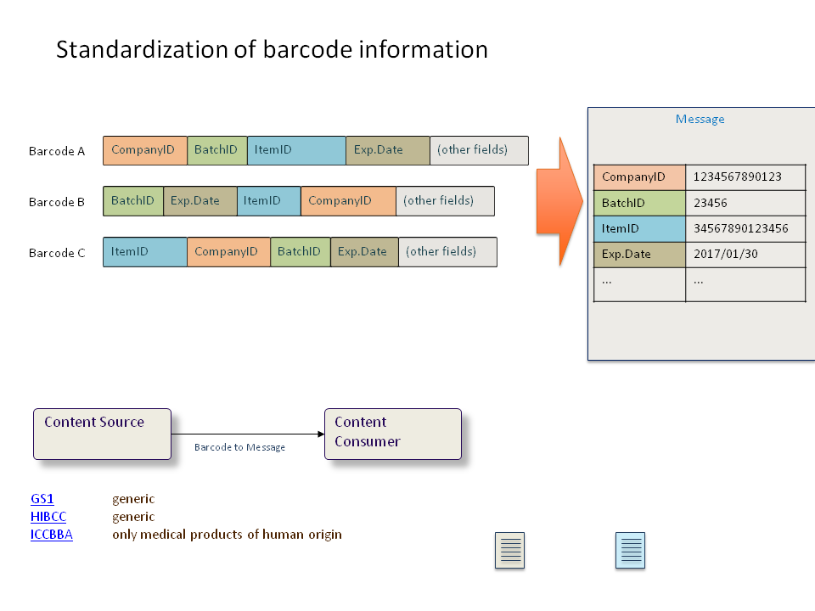

3. Key Use Case

*We distinguish four use cases that we will elaborate on in the appendix:*

1. *Barcode scanning of Pharmaceuticals at the point of care. This use case describes how a patient in a hospital bed is administered the pharmaceuticals needed for his or her treatment by scanning the ProductId, the CaregiverId and PatientId. The pharmaceuticals are prescribed by a doctor in a digital description system. When the nurse administers the drugs the system will check if it is the right patient and care giver for this drugs and also checks the dose and time of administration. This method guarantees a high level of patient safety ensuring the right patient getting the right drug at the right time in the right dose and by the right care giver*
2. *Traceability of Medical Devices in the Hospital  
   Patient A needs an operation. He will get a knee replacement. Before and during the operation the barcodes on the used products (knee, stitches, power tools) are scanned and the productId, batchnr and expiry date from the barcodes is registered in the EHR to link them to the patient. A manufacturer discovers a defect and notifies all parties of the need for a direct recall. The hospital takes the required steps to recall all products implanted as well as in inventory*
3. *Efficient Inventory Management  
   By using standardized information in an AIDC-format, it is possible to have 100% visibility on inventory. By registering expiry dates to the products, waste can be reduced with 80%. Please see business case ‘*[*Patient Safety and Efficiency in the OR*](https://www.gs1.nl/sites/default/files/GZHZ_Barcodes_BusinessCaseTraceerbaarheid.pdf)*’*
4. *Blood transfusion  
   Patient A needs a blood transfusion. The blood product is ordered inside the hospital and registered via the barcode. Before giving the blood to the patient, the productId, patientId and care giverId are being checked to make sure the right product will be given to the patient by the right care giver.*

4. Standards and Systems

The healthcare industry has adopted three systems for identification and coding.

**GS1 Standards in Healthcare**:

GS1 offers a common language to identify, capture and share supply chain data– ensuring important information is accessible, accurate and easy to understand. As a patient you are entitled to the best care. The use of GS1 standards in healthcare increases patient safety, drives supply chain efficiencies and improves the traceability of medicines and medical devices.

<http://www.gs1.org/healthcare>

<http://www.gs1.org/docs/healthcare/AIDC_Healthcare_Imp_Guide.pdf>

<http://www.gs1.org/traceability/healthcare-traceability/1-2-0>

**HIBCC**:

HIBCC®, the [Health Industry Business Communications Council](http://www.hibcc.org/?page_id=862), is an industry supported and internationally accredited nonprofit standards development organization with a global reach. HIBCC develops standards that meet the unique requirements of the world’s healthcare providers.

<http://www.hibcc.org/>

**ICCBBA**

The global language for the terminology, identification, coding and labeling of medical products of human origin, including blood, tissues, cellular therapy, human milk, organs and more.

ICCBBA is an international non-governmental organization (NGO) in official relations with the World Health Organization (WHO) that manages, develops, and licenses ISBT 128; the international information standard for the terminology, coding and labeling of medical products of human origin. ICCBBA manages the allocation of globally unique identifiers to licensed facilities and maintains the ISBT 128 Standard, international databases for Facility Identification Numbers and Product Description Codes, supporting documentation, and educational materials.

<https://www.iccbba.org/home>

5. Discussion

IHE would be a good organization to solve the problem because it can ensure the right standards are being used and by gathering the involved software vendors that are used in hospital’s care and logistic processes.

There is need for an IHE profile to support barcode scanning based on the above mentioned standards for identification and barcoding.

Instead of the Patient Care Device Domain, an alternative could be the ‘Hospital Supply ‘domain.

The IHE technical approach could be to provide a set of requirements for software vendors with which they can adapt their existing software solutions or embed into new solutions to the standards mentioned above: GS1, HIBC and ICCBBA.

*<What might the IHE technical approach be? Existing Actors? New Transactions? Additional Profiles?>*

*<What are some of the risks or open issues to be addressed?>*

**Appendix**

1. ***Scanning of Pharmaceuticals at the Point of Care***

*Use case 3 describes how a patient in a hospital bed is administered the pharmaceuticals needed for his or her treatment. The pharmaceuticals are prescribed by a doctor in a digital description system. When the nurse administers the drugs the system will check if it is the right patient and care giver for this drugs and also checks the dose and time of administration. This method guarantees a high level of patient safety ensuring the right patient getting the right drug at the right time in the right dose and by the right care giver*

|  |  |
| --- | --- |
| Use case 1 | Scanning of Pharmaceuticals at the Point of Care |
| Primary actor | Nurse, Physician |
| Description | Registering of prescribed pharmaceuticals to a patient in a hospital |
| Scope | Electronic Prescribing System, Hospital Pharmacy System, HIS |
| Level (User goal/sub function goal/summary level) | Pharmaceuticals provided with barcodes containing ProductId, Expiry Date and BatchNumber. Eventually also Serial Number. Patients and Care givers are identified with corresponding key. |
| Precondition | All pharmaceuticals carry barcodes (2D) with ProductId, Expiry Date and Batchnumber on the lowest level of the product: pill, ampule, bottle etc . Care giver and patients are identified with a standard Id. |
| Postcondition | The patient is administered the right drug in the right dose at the right time by the right care giver |
| Success scenario | 1. The nurse scans the pharmaceutical and the patient. She also scans her own ID on her card. The system checks if the pharmaceutical is the one that is prescribed by the physician and if the care giver is authorized to administer the drug. 2. When the system gives clearance, the nurse can proceed administering the drug to the patient 3. After administering the drug, it is recorded in the system linked to the patient. |

*Please also see* [*reference use case*](http://www.eahp.eu/press-room/report-uz-leuven-meeting-bedside-scanning) *of UZ Leuven on bedside scanning*

For pharmaceuticals: the supplier assigns uniform barcodes to all product levels as depicted below.

The lowest level will be scanned before administering to a patient (use case 3). The other levels are relevant for logistic purposes: warehousing, ordering, invoicing etc.

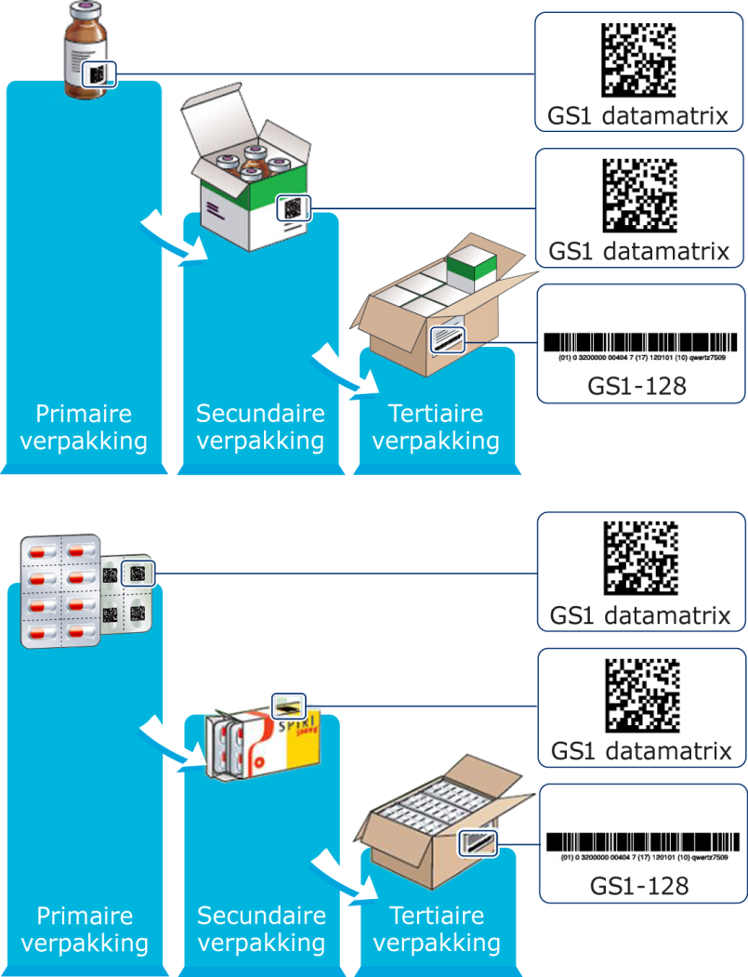

1. ***Traceability of Medical devices in the Hospital***

*Patient A needs an operation. He will get a knee replacement. Before and during the operation the barcodes on the used products (knee, stitches, power tools) are scanned and the information from the barcodes is registered in the EHR to link them to the patient. A manufacturer discovers a defect and notifies all parties of the need for a direct recall. The hospital takes the required steps to recall all products implanted as well as in inventory.*

|  |  |
| --- | --- |
| Use case 2 | Traceability of Medical devices in the hospital |
| Primary actor | OR nurse, OR staff |
| Description | Efficient and effective recall |
| Scope | HIS, ERP, HER |
| Precondition | * All medical devices carry barcodes with ProductId, Expiry Date and Batchnumber and/or serial number. * Care giver and patients are identified with a standard Id. * Locations are identified with proper key and captured in a barcode * Recording of ProductID, Batch/Lotnummer upon arrival in HIS, WMS and ERP systems; * Products are registered when used during operation. |
| Postcondition | The hospital is 100% in control for complete recall from inventory as well as all devices which have been implanted in patients within hours of notification. |
| Success scenario | 1. Manufacturer announces that device from batch 01234 could be defective and advises a direct recall preventing any further use of the device. All devices in stock must be returned directly to the manufacturer. All patients with this implant must be identified. 2. The ProductID in combination with Batchnumber 01234 is searched for in the inventory system by a OR staff member. The system automatically shows the member exactly where in the warehouse or inventory room the device can be found and how many should be present. 3. The traced inventory is then removed from the warehouse and sent directly back to the manufacturer. 4. This OR staff member signs for the shipment of the recall device with mentioning of the amount, ProductID and batch number 01234. 5. A qualified nurse searches the HIS for all patients which received the device from batch 01234. A complete list is generated within just hours. |

1. ***Efficient Inventory Management***

*Use case 2 shows the importance of efficient inventory management. The visability and management of medical devices in the OR Inventory Room ensures availability as well as usability.*

|  |  |
| --- | --- |
| Use case 3 | Efficient Inventory management |
| Primary actor | 1. Manager Logistics OR, OR assistent, OR nurse |
| Description | 1. Automated registering of medical devices |
| Scope | ERP/HIS/WMS/scanners |
| Precondition | * All medical devices carry barcodes with ProductId, Expiry Date and Batchnumber and/or serial number. * Barcode scanning of medical devices when arriving in the OR Inventory room or central ware house; * Recording of ProductId, Expiry date and Batch/lotnumber in HIS, WMS and ERP systems; * Receiving and sending of EDI-messages (Order, Order Response, Despatch Advice) |
| Postcondition | Visibility of medical Devices in Inventory, including batch and expiry dates. |
| Success scenario | 1. All necessary medical devices needed for the planned operations on patients are ordered; 2. When collecting the necessary items for the operation the products with the shortest expiry date are selected first. 3. All medical devices that are used during an operations are automatically reduced in the inventory system so at all times the inventory level is accurate; 4. When inventory level of a medical device reaches its minimum, the system will automatically send an order to the supplier to replenish. This way out-of-stock will be prevented; 5. When ordered medical devices are delivered, they will be automatically registered in the inventory system by scanning it’s barcodes which contain batch/lot number as well as expiry date 6. Inventory level of medical devices is at all times accurate; 7. Because the expiry date is registered via the barcode, the OR staff can manage which products need to be used first to prevent them going out of date. Waste can be reduced by around 80% leading to considerous cost savings. Please see [business case](https://www.gs1.nl/sectoren/gezondheidszorg/gs1-traceerbaarheid-ziekenhuizen) provided by GS1 Netherlands, 2011. |

1. ***Blood transfusion*** *Patient A needs a blood transfusion. The blood product is ordered inside the hospital and registered via the barcode. Before giving the blood to the patient, the productId, patientId and caregiverId are being checked to make sure the right product will be given to the patient by the right caregiver.*

This use case will be elaborated on in the detailed proposal after approvement of the brief proposal.

|  |  |
| --- | --- |
| Use case 4 | Blood transfusion |
| Primary actor |  |
| Description |  |
| Scope |  |
| Precondition |  |
| Postcondition |  |
| Success scenario |  |

*Example of a label on a medical device packaging, including the barcode containing the necessary information:*

